**CURRENCY EXCHANGE RATE FORECASTING BY USING SARIMA MODEL.**

Sanjai.S

UG Scholar

Rajalakshmi Engineering College

Shoban Kumaresan

UG Scholar

Rajalakshmi Engineering College

Siddarth V

UG Scholar

Rajalakshmi Engineering College

**Abstract**

In an increasingly globalized economy, currency exchange forecasting helps firms and investors manage risks and maximize rewards. It is a critical component of financial decision-making. Time series analytic techniques that can capture temporal patterns and exchange rate variations, like SARIMA (Seasonal Autoregressive Integrated Moving Average), have become more popular. This work provides a thorough analysis and implementation of the SARIMA algorithm.  
The SARIMA algorithm is a powerful tool for modeling and predicting the intricate dynamics of exchange rates because it combines seasonal fluctuations with the autoregressive (AR), differencing (I), and moving average (MA) components. SARIMA models can uncover underlying trends, seasonal patterns, and irregular variations by integrating historical exchange rate data. This can offer decision-makers insightful information.Data gathering, preprocessing, model selection, parameter estimates, and forecast evaluation are some of the processes in the methodology. To ensure data quality and consistency, historical exchange rate data is first gathered from reputable sources. Preprocessing methods are used to improve the analysis's dependability. Examples include eliminating outliers and managing missing data.  
The exchange rate time series' stationarity and seasonality characteristics are then used to choose the SARIMA model. The best SARIMA parameters are found by applying model selection criteria, such as the Akaike Information Criterion (AIC) and the Bayesian Information Criterion (BIC). Using the historical data, parameter estimation techniques like maximum likelihood estimation are used to calibrate the model parameters.

To sum up, the SARIMA algorithm-based currency exchange forecasting provides a reliable method for observing and projecting changes in exchange rates. Businesses and investors can optimize their strategy and decision-making processes in the global financial markets by utilizing sophisticated time series modeling tools and historical data.

**1. INTRODUCTION**

In today's worldwide economy, anticipating currency exchange rates is essential to financial planning and decision-making. To manage risks, maximize investments, and seize market opportunities, firms, investors, and regulators need to be able to forecast exchange rates with enough accuracy. Modern statistical techniques, like Seasonal Autoregressive Integrated Moving Average (SARIMA) models, have become effective instruments for time series analysis and foreign currency forecasting in recent years. With trillions of dollars changing hands every day, the foreign exchange market, or forex market, is the biggest and most liquid financial market in the world. Exchange rates, which show how much one currency is worth in relation to another, are affected by a wide range of variables, such as monetary policies, market sentiment, geopolitical developments, and economic data. Because of this, exchange rates display intricate and dynamic patterns that are marked by trends, seasonality, and erratic volatility, which makes predicting with accuracy difficult. Conventional methods of projecting currency exchange rates frequently depend on technical analysis, fundamental analysis, or a mix of the two. In order to determine the underlying worth of currencies, fundamental analysis looks at macroeconomic variables including interest rates, inflation, trade balances, and political stability. In contrast, technical analysis examines past price patterns and market trends to predict possible future moves.

Although technical and fundamental analysis can offer useful insights into currency markets, it can sometimes ignore the complex seasonal swings and temporal patterns present in exchange rate data. This is where SARIMA and other time series analysis techniques are useful. SARIMA is especially useful for modeling and forecasting time series data with seasonal trends because it incorporates seasonal changes into the fundamental ARIMA model.

**2. LITERATURE SURVEY**

Due to their intrinsic complexity, currency exchange rates are impacted by a wide range of factors, from geopolitical events to fundamentals in the economy.extend_more Precisely predicting these rates can yield significant information for individuals, businesses, and investors.extend_more The use of the SARIMA (Seasonal Autoregressive Integrated Moving Average) method for forecasting currency exchange rates is examined in this review.

Exchange rates and other financial time series data frequently show trends and seasonality. The power of SARIMA resides in its capacity to depict these traits.extend_more The autoregressive (AR) component simulates how historical exchange rates will affect current and future values.extend_more When dealing with non-stationary data, the integrated (I) portion differeces the data until it reaches stationarity (constant mean and variance over time).

Although SARIMA provides a strong foundation, researchers have looked for ways to increase the forecasting accuracy of the model. For predicting bitcoin exchange rates, Abu Bakar and Rosbi (2017) suggested a hybrid method combining SARIMA and a Genetic Algorithm (GA). More accurate forecasts may result from the GA's optimization of the SARIMA model's parameters, especially for highly volatile currencies like Bitcoin [3]. In order to forecast financial time series, Najamuddin et al. (2022) investigated a hybrid model that combines SARIMA and a Bidirectional Recurrent Neural Network (BRNN).extend_more With the SARIMA managing seasonality and the BRNN capturing complex non-linear interactions.

SARIMA has drawbacks in spite of its benefits. It makes the assumption that past and future values follow a linear relationship, which may not always be the case for exchange rates affected by unforeseen circumstances.exclamation_pen_spark Statistical knowledge is also needed for model selection and parameter estimates, which are essential for accurate projections.

SARIMA's power comes from its capacity to simulate seasonality and patterns in exchange rate data. Monthly data, for example, may show cyclical variations due to economic cycles. These recurring patterns can be taken into consideration by SARIMA, which could result in projections that are more accurate.

Etuk (2013) used the daily Euro-Dollar exchange rates as the basis for a SARIMA model. The model's good performance suggests that SARIMA has the ability to capture dynamics in the short term. In a similar vein, SARIMA's effectiveness in predicting Malaysia's electricity consumption was discovered by Ismail and Mahpol (2005), indicating its versatility beyond currency exchange.

Najamuddin and Fatima (2022) presented a hybrid model for financial time series forecasting that combines a Bidirectional Recurrent Neural Network (BRNN) with SARIMA. This method makes use of the advantages of machine learning and statistics. Some scholars support adding economic indicators as extra variables, even though SARIMA primarily focuses on historical exchange rate data. By incorporating the impact of more general economic patterns, this may increase forecast accuracy.

**3. Model architecture**

For forecasting currency exchange rates, the Seasonal Autoregressive Integrated Moving Average (SARIMA) model provides a structured method. In terms of currency exchange, the architecture is broken down as follows.

### **3.1 USD – INR Conversion Rate Analysis**

Since the USD - INR conversion rates data is what we are using, let's examine the historical conv

ersion rates between the two currencies. To begin, below figure 1 is a line graph that illustrates the historical pattern of conversion rates:

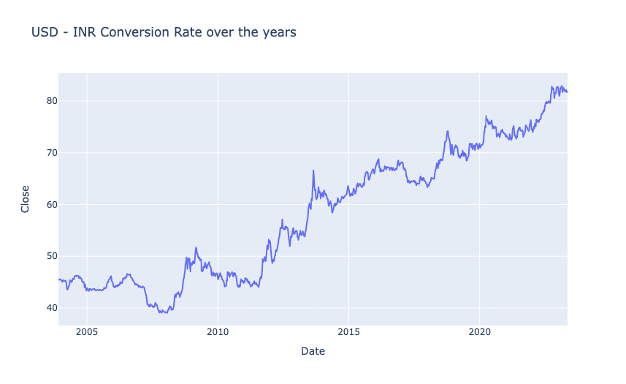

**3.2 Yearly Growth of USD – INR Conversion Rate**

As illustrated in Figure 2, The line chart shows the annual growth of the US dollar to Indian rupee conversion rate. The conversion rate fluctuates between -10% and 25% over a period from 2005 to 2020. There seems to be an increasing trend in the conversion rate over the years.

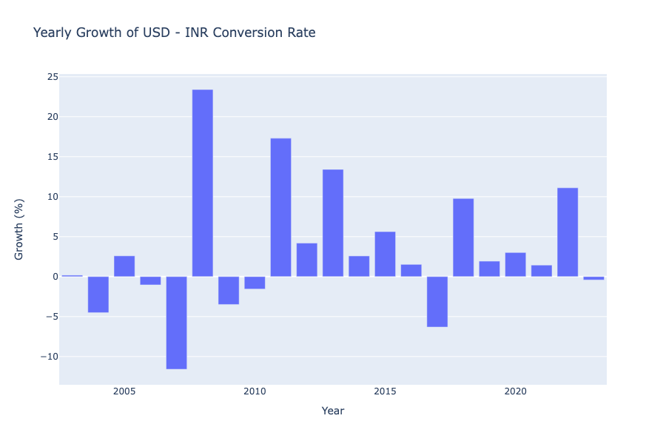

**3.3** Monthly Growth of USD – INR Conversion Rate

From Figure 3, The chart displays the average monthly growth of the USD-INR conversion rate. The growth fluctuates around 0.5% over a year, with occasional dips below zero.

We may observe that the value of the USD always decreases in January and March, increases annually in the second quarter, peaks in August and then declines in September, and climbs annually in the final quarter before declining once more in December.

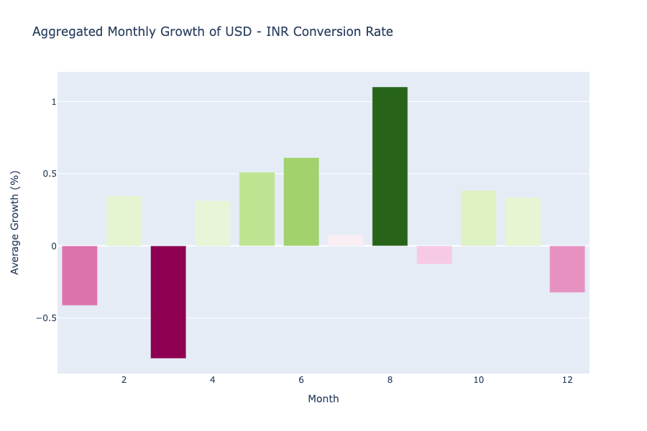

### 3.4 Forecasting Exchange Rates Using Time Series Forecasting

To forecast exchange rates, time series forecasting will be used. From the figure 4 , We must perform seasonal decomposition in order to determine the best time series forecasting model. This will enable us to see any long-term trends, recurrent patterns, and random fluctuations in the USD - INR exchange rate data.

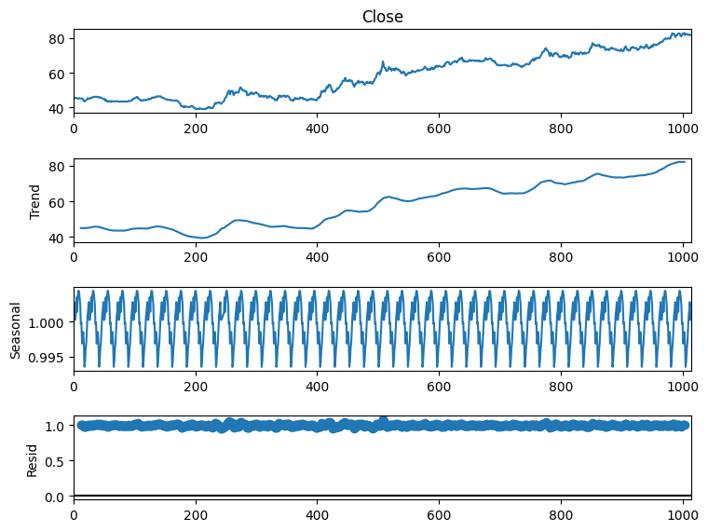

So we can see that there’s a seasonal pattern in this data. So SARIMA will be the most appropriate algorithm for this data. Before using SARIMA, we need to find p,d, and q values. Here, I will be using the pmdarima library to find these values. You can install this library in your Python environment by executing the command mentioned below.

3.5 INR TRAINING DATA AND PREDICTIONS

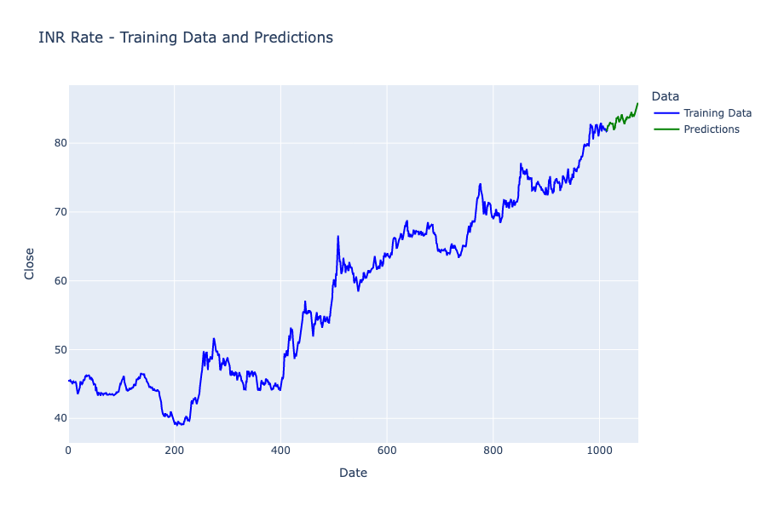

So from the figure 5, this is how you can use time series forecasting for the task of Currency Exchange Rate Forecasting using Python.

**4. Dataset**

It looks like from the figure 6, the data is a time series for currency exchange rates in the financial domain. The dates in the rows are probably daily dates spanning from December 2003 to March 2004. The currency rate in Indian rupees (INR) for one US dollar (USD) on that date is displayed in the columns. A stock or future tracking the exchange rate may be the subject of the additional columns for high, low, closing, and modified closing prices.

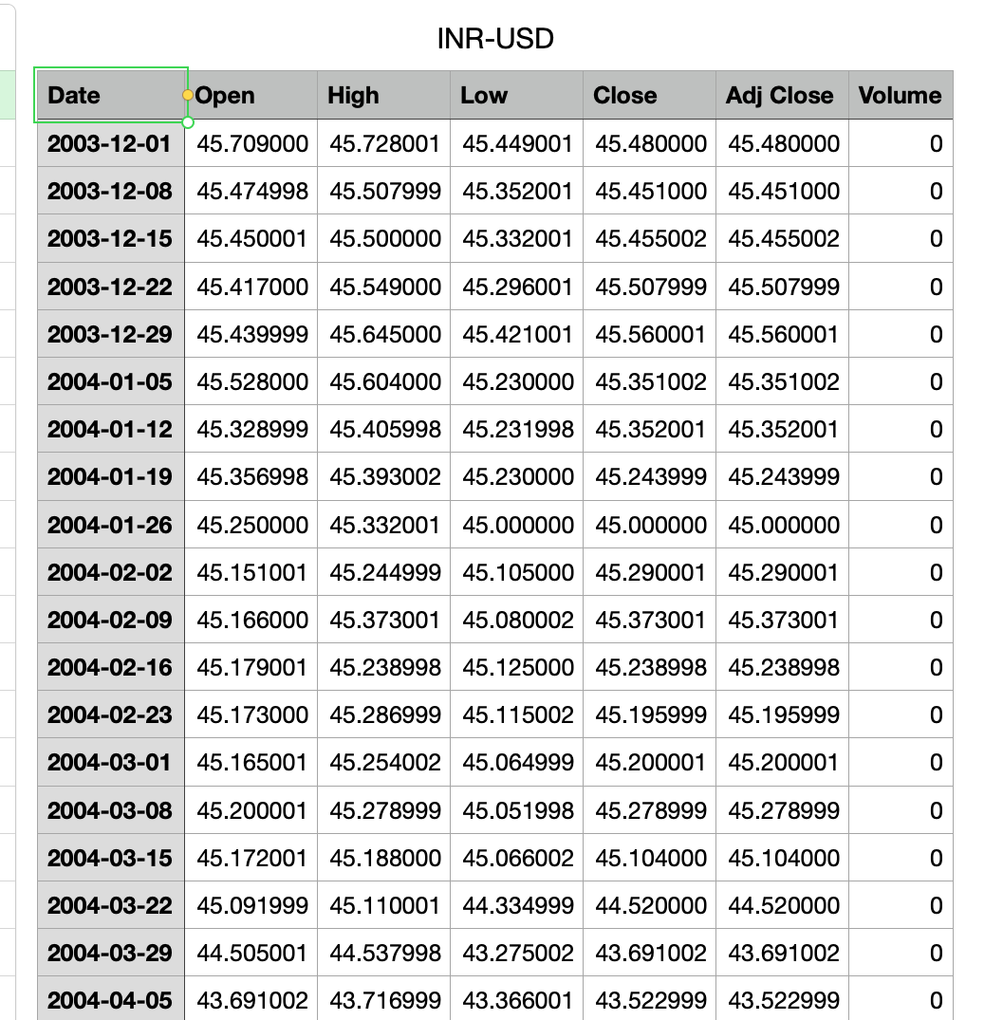

**5. Implementation Methods**

The system requirements for training and evaluating models are 32 GB of RAM, an Nvidia Titan Xp GPU, and an Intel Core i5-7700 CPU running at 3.60 GHz.

**5. RESULTS AND DISCUSSION**

Here’s how to find p,d, and q values using pmdarima

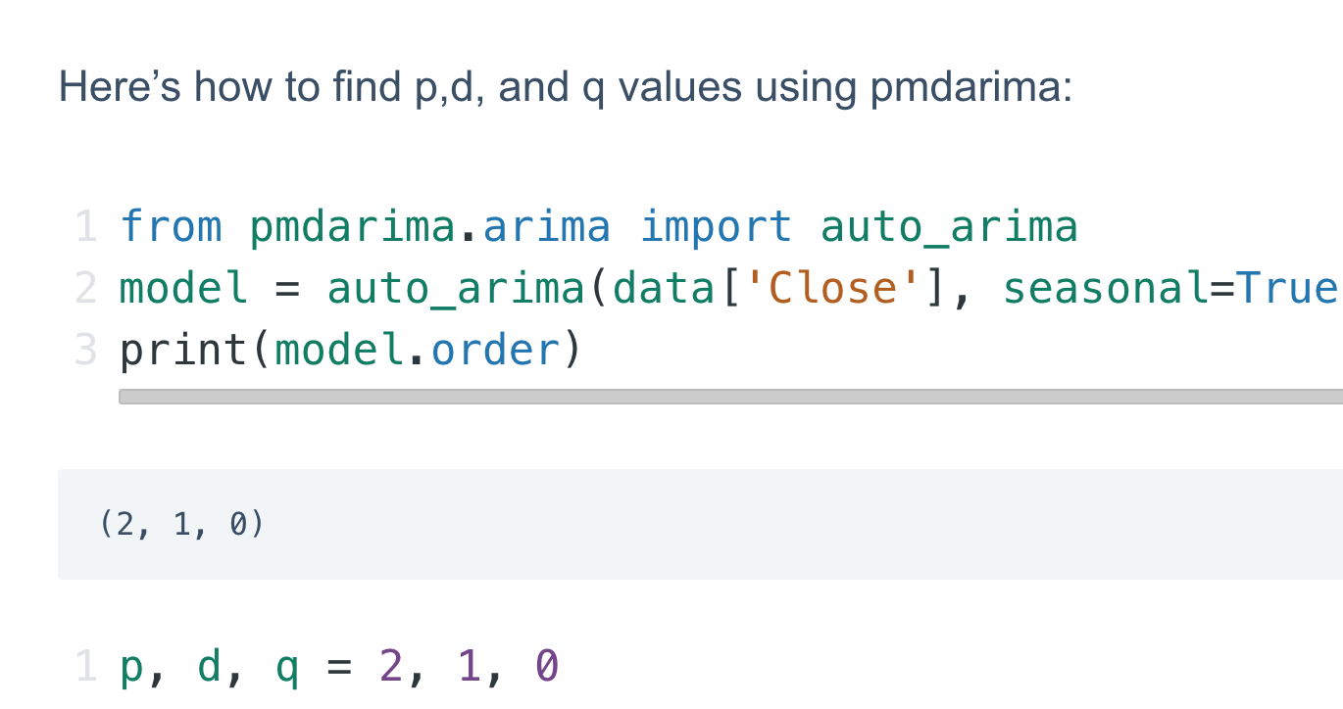

Now, here’s how to use SARIMA to train a model to forecast currency exchange rates.

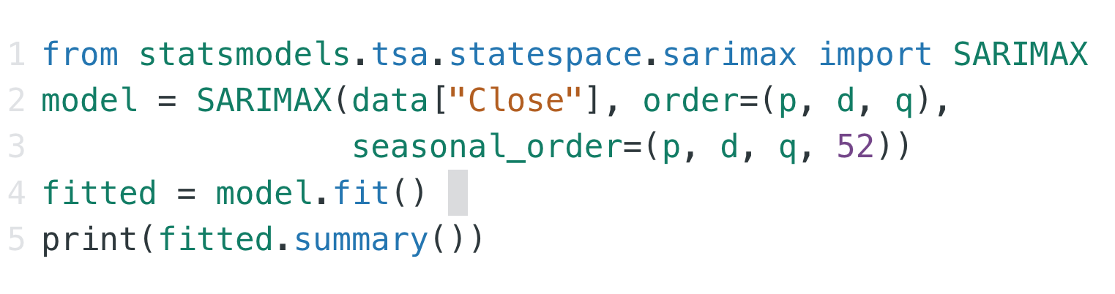

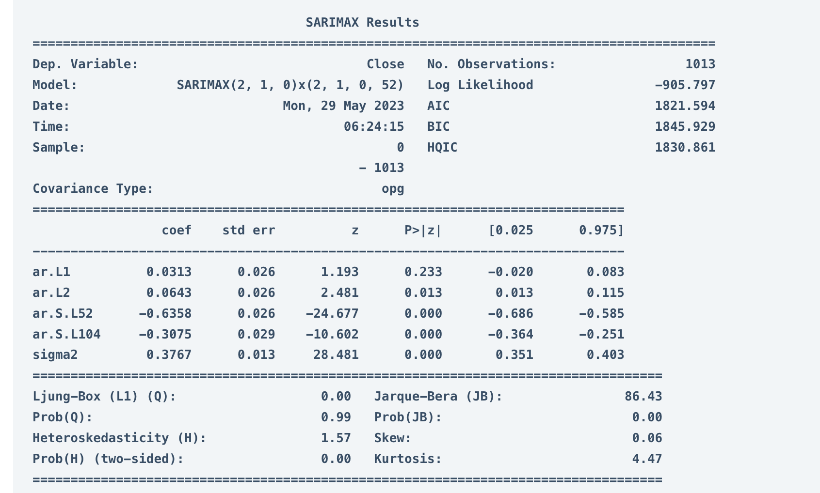

SARIMAX (2, 1, 0)x(2, 1, 0, 52) - This is the specific SARIMA model formula used in the analysis. It defines the number of autoregressive (AR) terms (2), differencing steps (1), and moving average (MA) terms (0) for the model itself, along with seasonal AR terms (2), seasonal differencing (1), and seasonal MA terms (0, 52). **Log Likelihood:** -1013.797 - This is a statistical measure used to assess how well the model fits the data. Lower values indicate a better fit.

Now here’s how to make predictions about future currency exchange rates:1

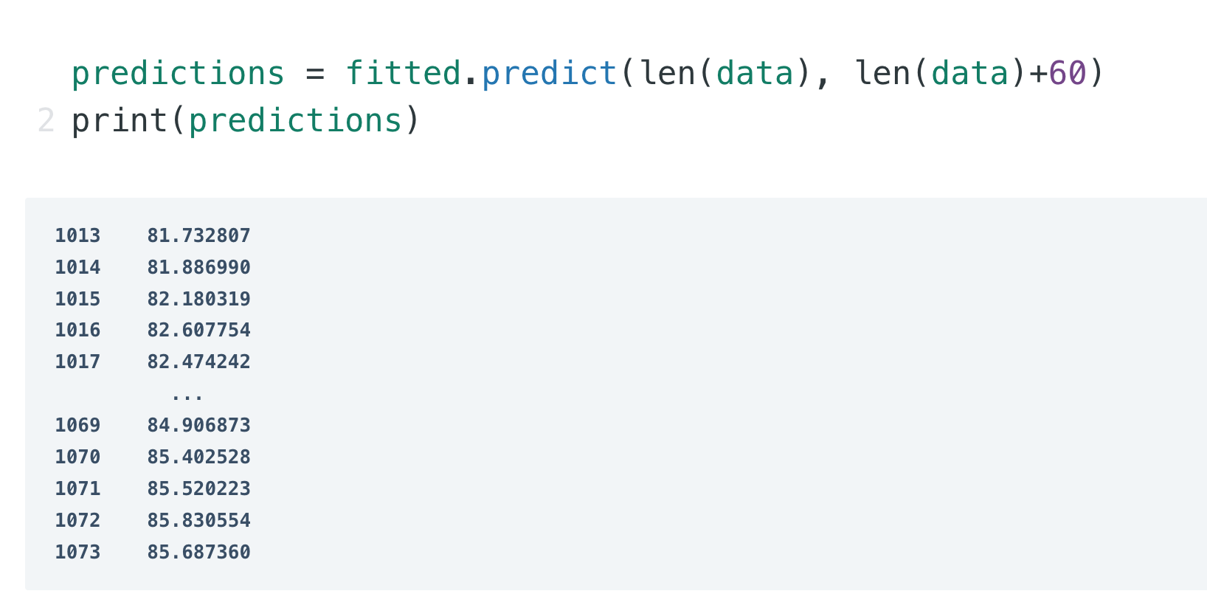

So this is how you can use time series forecasting for the task of Currency Exchange Rate Forecasting using Python.

**6. CONCLUSION**

Beyond forecasting, implementing USD-INR conversion rates requires careful consideration. Several methods cater to different needs. Currency converter APIs offer a convenient and accurate solution, fetching real-time or historical data through code integration. Web scraping provides a free alternative, but requires programming knowledge and maintenance due to potential website changes. Manual lookups on financial websites are readily available but lack real-time updates and may be cumbersome for bulk conversions. Lastly, storing historical data offline presents a cost-effective option, but the data can become outdated.

In conclusion, the USD-INR conversion rate remains a captivating puzzle for financial analysis. While SARIMA models offer valuable forecasting insights, understanding their limitations is crucial. When implementing these rates, the most suitable method depends on the desired level of accuracy, frequency of updates, and technical resources available. As the global economy continues to evolve, so too will the dance of the USD-INR conversion rate, demanding a blend of forecasting prowess, strategic implementation, and an awareness of the ever-changing economic landscape.

**REFERENCES**

1. Ciaparrone, Gioele, Francisco Luque Sánchez, Siham Tabik, Luigi Troiano, Roberto Tagliaferri, and Francisco Herrera. "Deep learning in video multi-object tracking: A survey." *Neurocomputing* 381 (2020): 61-88.
2. Pal, Sankar K., Anima Pramanik, Jhareswar Maiti, and Pabitra Mitra. "Deep learning in multi-object detection and tracking: state of the art." Applied Intelligence 51 (2021): 6400-6429
3. Kumar, Chethan, and R. Punitha. "Yolov3 and yolov4: Multiple object detection for surveillance applications." In 2020 Third international conference on smart systems and inventive technology (ICSSIT), pp. 1316-1321. IEEE, 2020.
4. Wang, Yongxin, Kris Kitani, and Xinshuo Weng. "Joint object detection and multi-object tracking with graph neural networks." In *2021 IEEE International Conference on Robotics and Automation (ICRA)*, pp. 13708-13715. IEEE, 2021.
5. Kumar, Ashwani, Zuopeng Justin Zhang, and Hongbo Lyu. "Object detection in real time based on improved single shot multi-box detector algorithm." *EURASIP Journal on Wireless Communications and Networking* 2020 (2020): 1-18.
6. Ravindran, Ratheesh, Michael J. Santora, and Mohsin M. Jamali. "Multi-object detection and tracking, based on DNN, for autonomous vehicles: A review." *IEEE Sensors Journal* 21, no. 5 (2020): 5668-5677.
7. Elhoseny, Mohamed. "Multi-object detection and tracking (MODT) machine learning model for real-time video surveillance systems." *Circuits, Systems, and Signal Processing* 39 (2020): 611-630.
8. Pramanik, Anima, Sankar K. Pal, Jhareswar Maiti, and Pabitra Mitra. "Granulated RCNN and multi-class deep sort for multi-object detection and tracking." *IEEE Transactions on Emerging Topics in Computational Intelligence* 6, no. 1 (2021): 171-181.
9. Li, Cui-jin, Zhong Qu, Sheng-ye Wang, and Ling Liu. "A method of cross-layer fusion multi-object detection and recognition based on improved faster R-CNN model in complex traffic environment." *Pattern Recognition Letters* 145 (2021): 127-134.
10. Mauri, Antoine, Redouane Khemmar, Benoit Decoux, Nicolas Ragot, Romain Rossi, Rim Trabelsi, Rémi Boutteau, Jean-Yves Ertaud, and Xavier Savatier. "Deep learning for real-time 3D multi-object detection, localisation, and tracking: Application to smart mobility." *Sensors* 20, no. 2 (2020): 532.
11. Huang, Kemiao, and Qi Hao. "Joint multi-object detection and tracking with camera-LiDAR fusion for autonomous driving." In 2021 IEEE/RSJ International Conference on Intelligent Robots and Systems (IROS), pp. 6983-6989. IEEE, 2021.
12. Joshi, R.C., Yadav, S., Dutta, M.K. and Travieso-Gonzalez, C.M., 2020. Efficient multi-object detection and smart navigation using artificial intelligence for visually impaired people. *Entropy*, *22*(9), p.941.
13. Wu, Jialian, Jiale Cao, Liangchen Song, Yu Wang, Ming Yang, and Junsong Yuan. "Track to detect and segment: An online multi-object tracker." In *Proceedings of the IEEE/CVF conference on computer vision and pattern recognition*, pp. 12352-12361. 2021.
14. Akshaya, D., Charanappradhosh, and J. Manikandan. "Social Distance Monitoring Framework Using YOLO V5 Deep Architecture." In Proceedings of International Conference on Recent Trends in Computing: ICRTC 2022, pp. 703-712. Singapore: Springer Nature Singapore, 2023.
15. Hou, Liang, Chunhua Chen, Shaojie Wang, Yongjun Wu, and Xiu Chen. "Multi-object detection method in construction machinery swarm operations based on the improved YOLOv4 model." Sensors 22, no. 19 (2022): 7294.
16. M. Bhavani, S. Ravikumar, S. Prithi, Y. Arockia Raj and B. Rajendiran, "Methodical Tamil Character Recognition Using Fabricated CNN Model," 2023 International Conference on Computer Communication and Informatics (ICCCI), Coimbatore, India, 2023, pp. 1-6, doi: 10.1109/ICCCI56745.2023.10128316.
17. Loganathan, Ganesh Babu, Tooraj Hassan Fatah, Elham Tahsin Yasin, and Nawroz Ibrahim Hamadamen. "To develop multi-object detection and recognition using improved GP-FRCNN method." In 2022 8th International Conference on Smart Structures and Systems (ICSSS), pp. 1-7. IEEE, 2022.
18. Anusha, S., N. Elakkiya, and R. Vijayakumar. "Separable Reversible Data Hiding in Encrypted Image Using Dual Data Embedding with Histogram Shifting." (2020)
19. Mauri, Antoine, Redouane Khemmar, Benoit Decoux, Madjid Haddad, and Rémi Boutteau. "Real-time 3D multi-object detection and localization based on deep learning for road and railway smart mobility." Journal of imaging 7, no. 8 (2021): 145.
20. Alex David, S., A. Begum, and S. Ravikumar. 2018. “Content Clustering for MRI Image Compression Using PPAM.” International Journal of Engineering and Technology(UAE) 7 (1.7 Special Issue 7): 125–27.
21. Yin, Mingjun, Shasha Li, Zikui Cai, Chengyu Song, M. Salman Asif, Amit K. Roy-Chowdhury, and Srikanth V. Krishnamurthy. "Exploiting multi-object relationships for detecting adversarial attacks in complex scenes." In proceedings of the IEEE/CVF international conference on computer vision, pp. 7858-7867. 2021.
22. Sudha, V., Akiladevi, R. Samuel, P, Nancy, P., An integrated IoT blockchain security technique based on decentralized applications, Internet of Everything: Smart Sensing Technologies, pp. 123-143, 2022.
23. S. D. Sorna, B. Bhuvaneswaran, A. R. Manoj and S. Pooja, "MonuAR:M.A.R Application for Visualising 3D Monuments," 2023 International Conference on Networking and Communications (ICNWC), Chennai, India, 2023, pp. 1-10, doi: 10.1109/ICNWC57852.2023.10127425.
24. Babu, R., Jayashree Kannappan, Brahmadesam Viswanathan Krishna, and K. Vijay. "An efficient spam detector model for accurate categorization of spam tweets using quantum chaotic optimization-based stacked recurrent network." Nonlinear Dynamics (2023): 1-18.
25. Luo, Chenxu, Xiaodong Yang, and Alan Yuille. "Exploring simple 3d multi-object tracking for autonomous driving." In Proceedings of the IEEE/CVF International Conference on Computer Vision, pp. 10488-10497. 2021.
26. Jha, Santosh Kumar. "Advances in Object Detection Algorithms–A Brief Survey." (2022).
27. Babu, R., Samuel, Prithi and Jayashree, K. "Cognitive Authentication for Smart Healthcare System". Deep Learning for Cognitive Computing Systems: Technological Advancements and Applications, edited by M.G. Sumithra, Rajesh Kumar Dhanaraj, Celestine Iwendi and Anto Merline Manoharan, Berlin, Boston: De Gruyter, 2023, pp. 149-164. https://doi.org/10.1515/9783110750584-009
28. Lu, Yantao. "Human Activity Recognition from Egocentric Videos and Robustness Analysis of Deep Neural Networks." PhD diss., Syracuse University, 2020.
29. Campoverde, Andres, and Gabriel Barros. "Detection and classification of urban actors through TensorFlow with an android device." In Conference on Information Technologies and Communication of Ecuador, pp. 167-181. Cham: Springer International Publishing, 2019.
30. Praliyev, Nurgeldy, Viktor Remeli, and Zsolt Szalay. "Distance estimation using mono camera at different altitudes and pitch angles." In 2021 IEEE 19th World Symposium on Applied Machine Intelligence and Informatics (SAMI), pp. 000405-000412. IEEE, 2021.